**Ideation and Pitching Tips**

# **Ideation and Exploration**

Hi teams, as you go through the process of focusing in on a specific problem to solve, this diagram might help you. It's very easy to jump straight into "solution mode" but this can lead to solving the wrong problem. My tip is to **timebox** time to get creative, explore & test and (very important) focus in on solving one challenge. We need to timebox because you only have 48 hours and you need to use your time wisely. Sometimes it's not actually a case of killing bad ideas, but choosing one good idea you can focus on out of several.This can be hard, but you will have a better outcome by focusing effort on one thing than spreading it out across a lot of things.

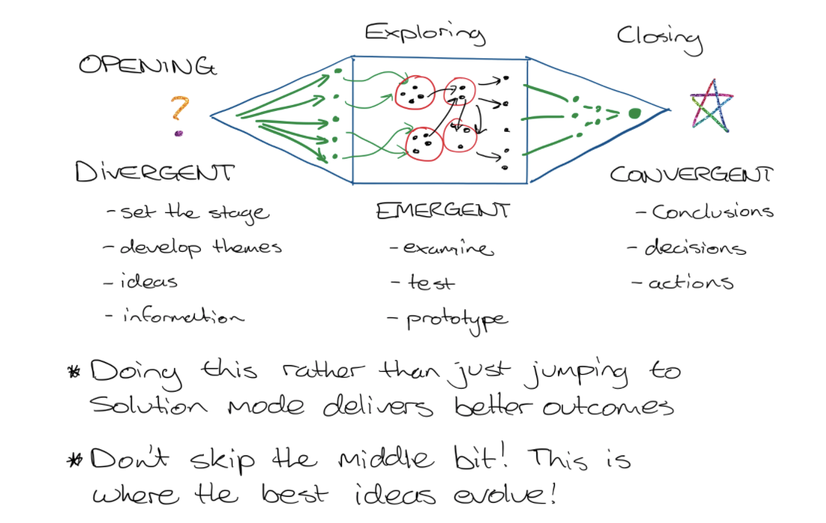

# **Pitching**

Hi teams - quick tip: For you video presentations, use a script. This helps you to keep things flowing, know exactly what your timings will be and reduce nerves because you're not having to "wing it" and worrying about whether you remembered a point or not. If you're recording a powerpoint, don't pause to allow a slide to transition. You should mark in your script when a slide should be moved. This helps your dialogue to flow and will reduce wasted time waiting for a slide.  
  
Very basic way to break up your presentation / pitch. Draw a timeline and then work backwards from the time limit. Different sections will be different lengths. Also not everything has to be demonstrated in a pitch - Don't waste time with logins or setting up: Go straight to the hotness! :fire::fire::fire:

One technique you might want to leverage to distil your message is "Situation, Complication, Question, Answer" - it's pretty popular, easy to follow and I'm sure many already have applied it. Remember focus in on the essentials. :+1::dart::trophy:  
  
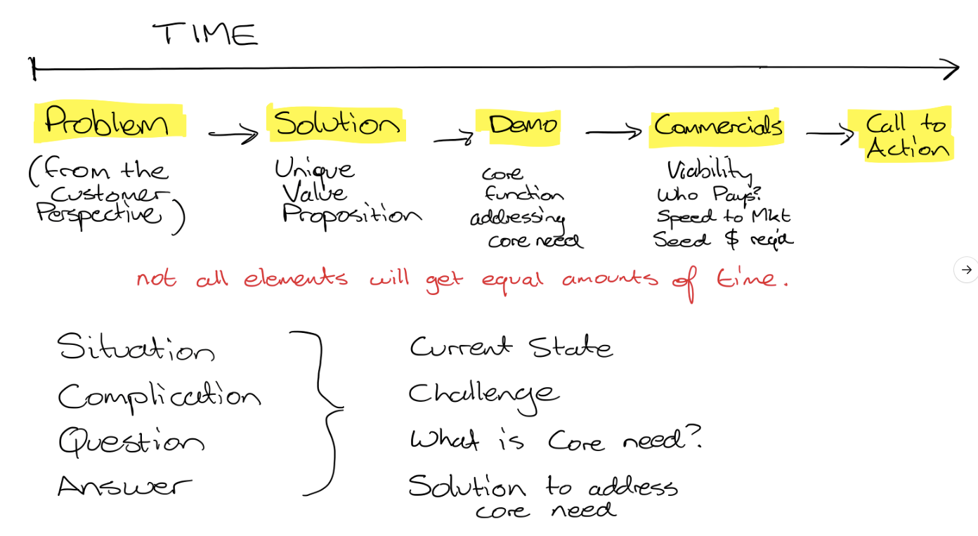

# Liedtka & Ogilvie on Idea Selection:

# Ink Drawings Ink Drawings Ink Drawings Ink Drawings Ink Drawings Ink Drawings Ink Drawings Ink Drawings Ink Drawings Ink Drawings Ink Drawings Ink Drawings Ink Drawings Ink Drawings Ink Drawings Ink Drawings Ink Drawings Ink Drawings Ink Drawings Ink Drawings Ink Drawings Ink Drawings Ink Drawings Ink Drawings Ink Drawings Ink Drawings Ink Drawings Ink Drawings Ink Drawings Ink Drawings Ink Drawings Ink Drawings Ink Drawings Ink Drawings Ink Drawings Ink Drawings Ink Drawings Ink Drawings Ink Drawings Ink Drawings Ink Drawings Ink Drawings Ink Drawings Ink Drawings Ink Drawings Ink Drawings Ink Drawings Ink Drawings Ink Drawings Ink Drawings Ink Drawings Ink Drawings Ink Drawings Ink Drawings Ink Drawings Ink Drawings Ink Drawings Ink Drawings Ink Drawings Ink Drawings Ink Drawings Ink Drawings Ink Drawings Ink Drawings Ink Drawings Ink Drawings Ink Drawings Ink Drawings Ink Drawings Ink Drawings Ink Drawings Ink Drawings Ink Drawings Ink Drawings Ink Drawings Ink Drawings Ink Drawings Ink Drawings Ink Drawings Ink Drawings Ink Drawings Ink Drawings Ink Drawings Ink Drawings Ink Drawings Ink Drawings Ink Drawings Ink Drawings Ink Drawings Ink Drawings Ink Drawings Ink Drawings Ink Drawings Ink Drawings Ink Drawings Ink Drawings Ink Drawings Ink Drawings Ink Drawings Ink Drawings Ink Drawings Ink Drawings Ink Drawings Ink Drawings Ink Drawings Ink Drawings Ink Drawings Ink Drawings Ink Drawings Ink Drawings Ink Drawings Ink Drawings Ink Drawings Ink Drawings Ink Drawings Ink Drawings Ink Drawings Ink Drawings Ink Drawings Ink Drawings Ink Drawings Ink Drawings Ink Drawings Ink Drawings Ink Drawings Ink Drawings Ink Drawings Ink Drawings Ink Drawings Ink Drawings Ink Drawings Ink Drawings Ink Drawings Ink Drawings Ink Drawings Ink Drawings Ink Drawings Ink Drawings Ink Drawings Ink Drawings Ink Drawings Ink Drawings Ink Drawings Ink Drawings Ink Drawings Ink Drawings Ink Drawings Ink Drawings Ink Drawings Ink Drawings Ink Drawings Ink Drawings Ink Drawings Ink Drawings Ink Drawings Ink Drawings Ink Drawings Ink Drawings Ink Drawings Ink Drawings Ink Drawings Ink Drawings Ink Drawings Ink Drawings Ink Drawings Ink Drawings Ink Drawings Ink Drawings Ink Drawings Ink Drawings Ink Drawings Ink Drawings Ink Drawings Ink Drawings Ink Drawings Ink Drawings Ink Drawings Ink Drawings Ink Drawings Ink Drawings Ink Drawings Ink Drawings Ink Drawings Ink Drawings Ink Drawings Ink Drawings Ink Drawings Ink Drawings Ink Drawings Ink Drawings Ink Drawings Ink Drawings Ink Drawings Ink Drawings Ink Drawings Ink Drawings Ink Drawings Ink Drawings Ink Drawings Ink Drawings Ink Drawings Ink Drawings Ink Drawings Ink Drawings Ink Drawings Ink Drawings Ink Drawings Ink Drawings Ink Drawings Ink Drawings Ink Drawings Ink Drawings Ink Drawings Ink Drawings Ink Drawings Ink Drawings Ink Drawings Ink Drawings Ink Drawings Ink Drawings Ink Drawings Ink Drawings Ink Drawings Ink Drawings Ink Drawings Ink Drawings Ink Drawings Ink Drawings Ink Drawings Ink Drawings Ink Drawings Ink Drawings Ink Drawings Ink Drawings Ink Drawings Ink Drawings Ink Drawings Ink Drawings Ink Drawings Ink Drawings Ink Drawings Ink Drawings Ink Drawings Ink Drawings Ink Drawings Ink Drawings Ink Drawings Ink Drawings Ink Drawings Ink Drawings Ink Drawings Ink Drawings Ink Drawings Ink Drawings Ink Drawings Ink Drawings Ink Drawings Ink Drawings Ink Drawings Ink Drawings Ink Drawings Ink Drawings Ink Drawings Ink Drawings Ink Drawings Ink Drawings Ink Drawings Ink Drawings Ink Drawings Ink Drawings Ink Drawings Ink Drawings Ink Drawings Ink Drawings Ink Drawings Ink Drawings Ink Drawings Ink Drawings Ink Drawings Ink Drawings Ink Drawings Ink Drawings Ink Drawings Ink Drawings Ink Drawings Ink Drawings Ink Drawings Ink Drawings Ink Drawings Ink Drawings Ink Drawings Ink Drawings Ink Drawings Ink Drawings Ink Drawings Ink Drawings Ink Drawings Ink Drawings Ink Drawings Ink Drawings Ink Drawings Ink Drawings Ink Drawings Ink Drawings Ink Drawings Ink Drawings

A small tool you might consider using as you focus in on your selected challenge is a cut-down version of the process by Liedtka and Ogilvie in their book "Designing for Growth", several teams I have mentored have used this method as a way to DIVERGE, EXPLORE (+Test) and CONVERGE on their chosen solution.

* **What is** - what's the current state of play and the challenges faced?
* **What if** - Explore solutions, be creative. Don't constrain your thinking just yet…
* **What wows** - What are the ideas that would make an impact for your stakeholders?
* **What works** - you might not be able to solve the whole problem in 48 hours, but what can you realistically prove / demonstrate the feasibility of your solution and the positive impact it can have?

# Low Fidelity vs. High Fidelity Mock Ups

Low fidelity mock ups and prototypes are great for validation. Why? Because when something looks scrappy and thrown together, whoever is looking at your prototype is not having several unconscious processes going on in the brain: Chief among them is not wanting to upset you. This leads to "It's good" or "it's fine" rather than any deep validation. When you show someone something sketched or put together with bubble gum & chicken wire, the person you're validating with will know it's safe to critique. You will get a lot more useful feedback with low-fi mockups. :-)

